**Q1)** Git Branching Strategy

**Branching strategy:**

A Git branching strategy helps organize work on a project by using different branches for different purposes. Here's a common and simple one:

**1)main Branch**:

* This is the production-ready branch.
* Code here is always stable and deployable.

**2)developer Branch:**

* This branch is used to merge all features under development.
* Acts as an integration branch for all new features before they are pushed to main.

**3)feature Branches**:

* These are individual branches for each new feature or bug fix.
* Created from the developer branch.
* Developers work on these branches independently, then merge back into developer when the feature is complete.

Create a repository  
Gitrepo: https://github.com/Bhargavkulla/q1/tree/feature/login



Create the branching strategy as mentioned above



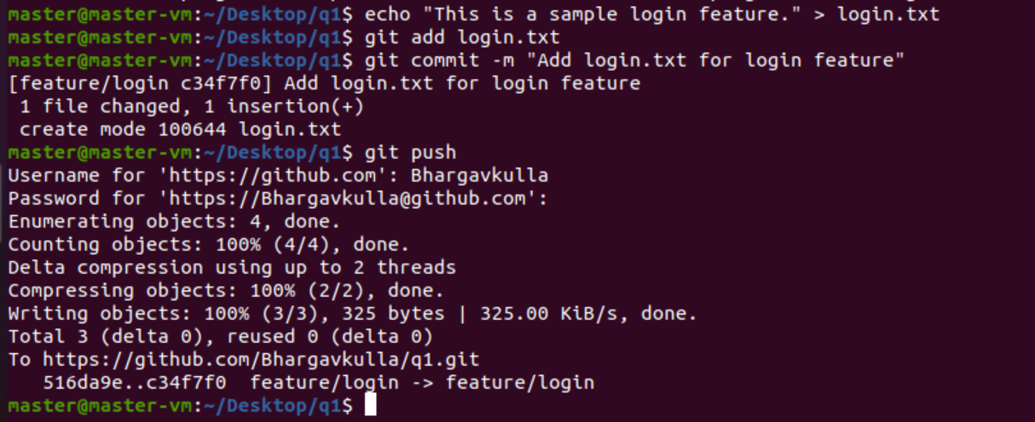

Git repo branching strategy

